Fruit Dataset

Description

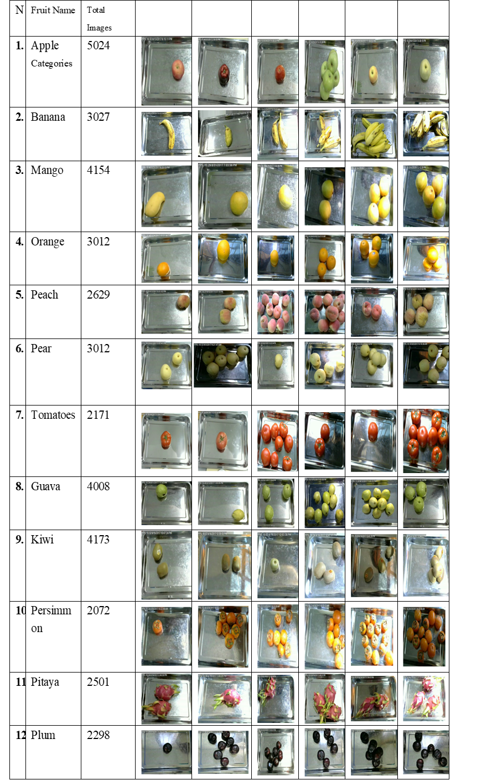**1**.Fruit Sample Table

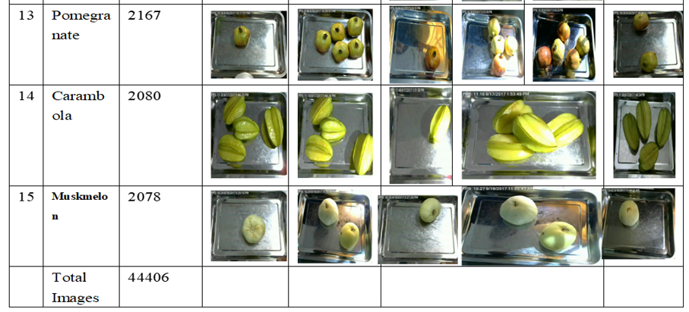

**Dataset** (Total Dataset samples for 15 types of Fruits)

|  |  |  |  |  |  |
| --- | --- | --- | --- | --- | --- |
| S/N | Fruit Name | Fruit Images | S/N | Fruit Name | Fruit Images |
| 1 | Apple | 5025 | 9 | Kiwi | 4173 |
| 2 | Banana | 3027 | 10 | Persimmon | 2072 |
| 3 | Mango | 4154 | 11 | Pitaya | 2501 |
| 4 | Orange | 3012 | 12 | Pomegranate | 2298 |
| 5 | Peach | 2929 | 13 | Carambola | 2167 |
| 6 | Pear | 3012 | 14 | Muskmelon | 2078 |
| 7 | Tomatoes | 2171 | 15 | Guava | 4008 |
| 8 | Plum | 2298 |  | **Total Images for 15 Categories of Images** | **44406** |

Apple Fruits

|  |  |  |  |  |  |
| --- | --- | --- | --- | --- | --- |
| Fruit Name | Images |  |  |  |  |
| Apple A | 957 |  |  |  |  |
| Apple B | 740 |  |  |  |  |
| Apple C | 870 |  |  |  |  |
| Apple D | 1033 |  |  |  |  |
| Apple E | 664 |  |  |  |  |
| Apple F | 1338 |  |  |  |  |

## 2 Dataset formats

All the images are in PNG format

## 3 Directory Path

There are 15 different kind of fruits consisting of 44406 images. For 15 different categories there are 15 folders in our dataset and their sub-categories of fruits were kept in sub-folders like for apple there is one folder and inside the main folder there are six sub-folders for sub-categories.

Example

Apple (Main folder)

Apple A

Apple B

Apple C

Apple D Sub-folders

Apple E

Apple F

Sub-categories of all fruits are exit in their relevant sub-folders

## 4.Image Size

The original size of the images is **320×258×3** here 3 represent channel all the images is color image so, for color images channel=3

**Note**

If you need further information regarding dataset please

Feel free to contact me

Email Id israrhussain46@gmail.com